**Zadanie 5 – Porovnávanie QOS mechanizmov**

**Vladimír Jančich, Roman Kasala**

# Topológia

Dvojica smerovačov prepojená sériovým káblom na rozhraní s0/0/0. Koncové počítače sú k obom smerovačom pripojené na rozhraní fa0/0. IP adresa počítača pripojeného k R1 bola 10.0.1.10/24. Rozhranie fa0/0 smerovača R1 malo IP adresu 10.0.1.1/24. Rozhranie s0/0/0 smerovača R1 malo IP adresu 10.0.12.1/24 a rozhranie s0/0/0 smerovača R2 dostalo IP adresu 10.0.12.2/24. Rozhranie fa0/0 smerovača R2 malo IP adresu 10.0.2.1/24 a počítač pripojený k tomuto rozhraniu používal IP adresu 10.0.2.10/24. Medzi smerovačmi fungovalo jednoduché statické smerovanie a sériové rozhranie bolo limitované na priepustnosť 128 Kbps. Postarali sa o to príkazy clock rate 128000 a bandwidth 128.

**R1**

**R2**

**10.0.1.0 / 24**

**10.0.2.0 / 24**

**10.0.12.0 / 24**

**128 k**

**clock rate**

**bandwidth**

**Sender**

**Reciever, WS**

**S0**

**S0**

**f0**

**f0**

# Zadanie 1

* Zmeňte rýchlosť sériovej linky a odsledujte či a ako sa zmení HW front TxRing pre dané rozhranie - konkrétne sledujeme jeho veľkosť (môže robiť každý na svojom smerovači na

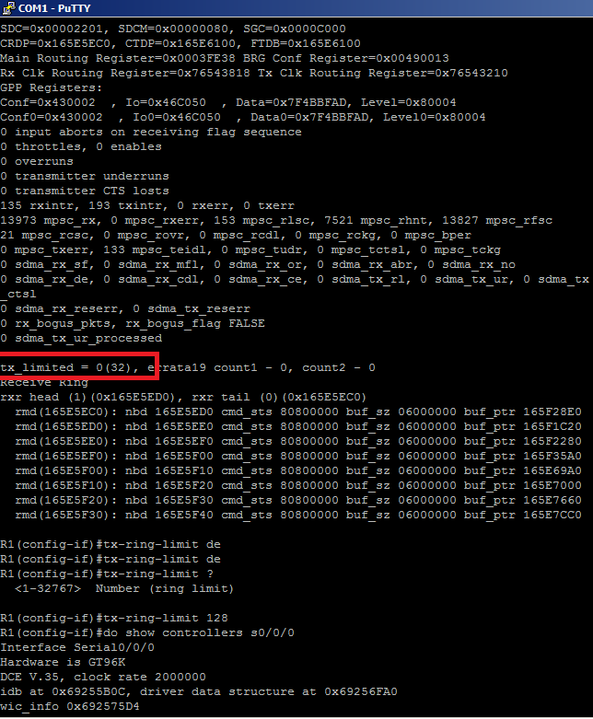

**Obrázok 1 Príkazom tx-ring-limit sme zmenili veľkosť HW frontu**

# Zadanie 2

* Preskúmajte defaultné nastavenia WFQ

Sériové rozhranie bolo limitované na šírku pásma 128 Kbps a na rozhraní s0/0/0 smerovača R1 sme nastavili WHQ mechanizmu cez nasledujúcu policy-mapu:

policy-map WFQ

class class-default

fair-queue

Následne sme vytvorenú policy-mapu aplikovali na rozhranie:

service-policy output WFQ

Príkazom show int s0/0/0 sme sa snažili zistiť parametre pre CDT, hold-queue a pre maximálny počet frontov. V nošvích IOSosch od verzie 15.5 však už parameter CDT nie je dostupný.

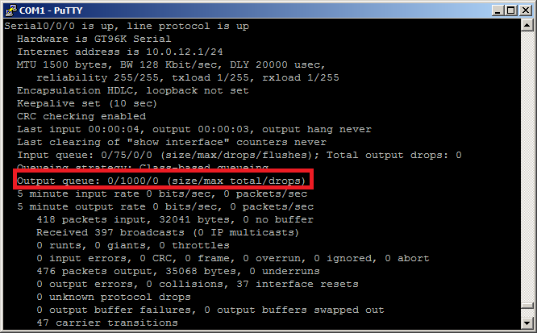

# Zadanie 3

V nasledujúcich krokoch budeme experimentovať s 3 QOS mechanizmos – s FIFO, PQ a WHQ. V každom z nich púšťame cez D-ITG 2 toky, pričom skúmame 2 scenáre. Pri prvom je intenzota oboch tokov nastavená tak, aby sa oba vmestili do kapacity linky 128 Kbps. V druhom sú toky nastavené tak, aby sa nevmestili oba naraz.

Konkrétne to znamená, že v prvom scenári púšťame 2 UDP roky, pričom ich intenzita je 12 paketov za sekudnu a veľkosť paketu je 512B. Intenzita takéhoto toku je 43 Kbps a teda dokopy 86 Kbps. V druhom scenári majú oba toky intenzitu 21 paketov za sekundu a traffic jedného toku je tak X Kbps.

Zároveň vždy zapíname aj logger a sledujeme straty a oneskorenia pri tokoch, ktoré sa do linky nezmestia.

* Experimenty s FIFO

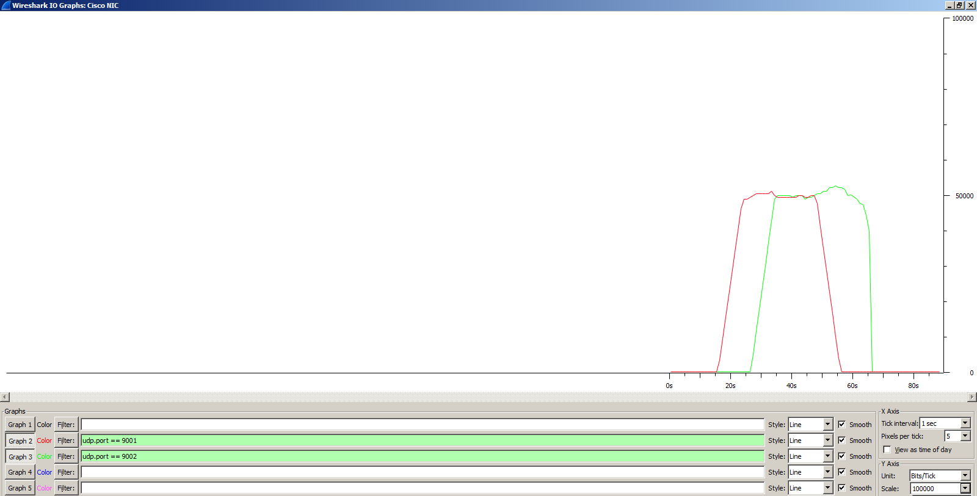

**Obrázok 2 Pri intenzite paketov 12 pkt/s nemá rozhranie problém a prevádzka dosahuje maximálne stanovených 50 Kbps**

Nasleduje výpis z loggera pre oba toky. Straty sú nulové

ITGDec version 2.8.1 (r1023)

Compile-time options:

----------------------------------------------------------

Flow number: 1

From 10.0.1.10:62717

To 10.0.2.10:9001

----------------------------------------------------------

Total time = 31.111000 s

Total packets = 360

Minimum delay = -53.828000 s

Maximum delay = -52.602000 s

Average delay = -53.222244 s

Average jitter = 0.004997 s

Delay standard deviation = 0.343425 s

Bytes received = 184320

Average bitrate = 47.396741 Kbit/s

Average packet rate = 11.571470 pkt/s

Packets dropped = 0 (0.00 %)

Average loss-burst size = 0.000000 pkt

----------------------------------------------------------

----------------------------------------------------------

Flow number: 2

From 10.0.1.10:62718

To 10.0.2.10:9002

----------------------------------------------------------

Total time = 31.220000 s

Total packets = 360

Minimum delay = -59.184000 s

Maximum delay = -57.877000 s

Average delay = -58.585628 s

Average jitter = 0.005404 s

Delay standard deviation = 0.361433 s

Bytes received = 184320

Average bitrate = 47.231262 Kbit/s

Average packet rate = 11.531070 pkt/s

Packets dropped = 0 (0.00 %)

Average loss-burst size = 0.000000 pkt

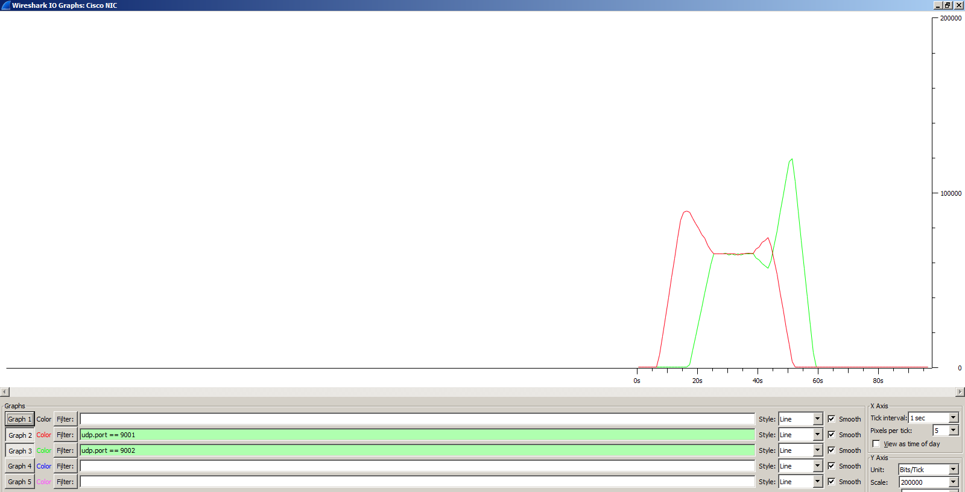

**Obrázok 3 FIFO pri 2 tokoch s intenzitou 21pkt/s**

Nasleduje výpis z loggera pre FIFO a intenzitu tokov 21pkt/s. Tu už došlo k zahadzovaniu paketov a to najmä z prvého toku (takmer 10%).

ITGDec version 2.8.1 (r1023)

Compile-time options:

----------------------------------------------------------

Flow number: 1

From 10.0.1.10:51702

To 10.0.2.10:9001

----------------------------------------------------------

Total time = 36.231000 s

Total packets = 567

Minimum delay = -54.147000 s

Maximum delay = -47.781000 s

Average delay = -51.767915 s

Average jitter = 0.012898 s

Delay standard deviation = 2.290924 s

Bytes received = 290304

Average bitrate = 64.100687 Kbit/s

Average packet rate = 15.649582 pkt/s

Packets dropped = 62 (9.86 %)

Average loss-burst size = 1.291667 pkt

----------------------------------------------------------

----------------------------------------------------------

Flow number: 2

From 10.0.1.10:51703

To 10.0.2.10:9002

----------------------------------------------------------

Total time = 33.066000 s

Total packets = 623

Minimum delay = -59.543000 s

Maximum delay = -53.468000 s

Average delay = -55.554934 s

Average jitter = 0.017735 s

Delay standard deviation = 1.751001 s

Bytes received = 318976

Average bitrate = 77.173169 Kbit/s

Average packet rate = 18.841106 pkt/s

Packets dropped = 7 (1.11 %)

Average loss-burst size = 1.166667 pkt

----------------------------------------------------------

__________________________________________________________

**************** TOTAL RESULTS ******************

__________________________________________________________

Number of flows = 2

Total time = 43.315000 s

Total packets = 1190

Minimum delay = -59.543000 s

Maximum delay = -47.781000 s

Average delay = -53.750531 s

Average jitter = 0.090337 s

Delay standard deviation = 2.771869 s

Bytes received = 609280

Average bitrate = 112.530070 Kbit/s

Average packet rate = 27.473162 pkt/s

Packets dropped = 69 (5.48 %)

Average loss-burst size = 1.277778 pkt

Error lines = 0

* Experimentovanie s PQ

Na novších IOSoch od verzie 15.5 sa PQ konfiguruje cez policy-mapy. Predtým, sme však ešte museli vytvoriť ACL pre naše 2 toky

access-list 101 permit udp any any eq 9001

access-list 102 permit udp any any eq 9002

Následne sme vytvorili class-mapy pre tieto toky:

class-map match-all pri2

match access-group 102

class-map match-all pri1

match access-group 101

A nakoniec policy-mapu, ktorú sme aplikovali vo výstupnom smere z R1 na rozhranie s0/0/0

policy-map PQ

class pri1

priority level 1

class pri2

priority level 2

service-policy output PQ

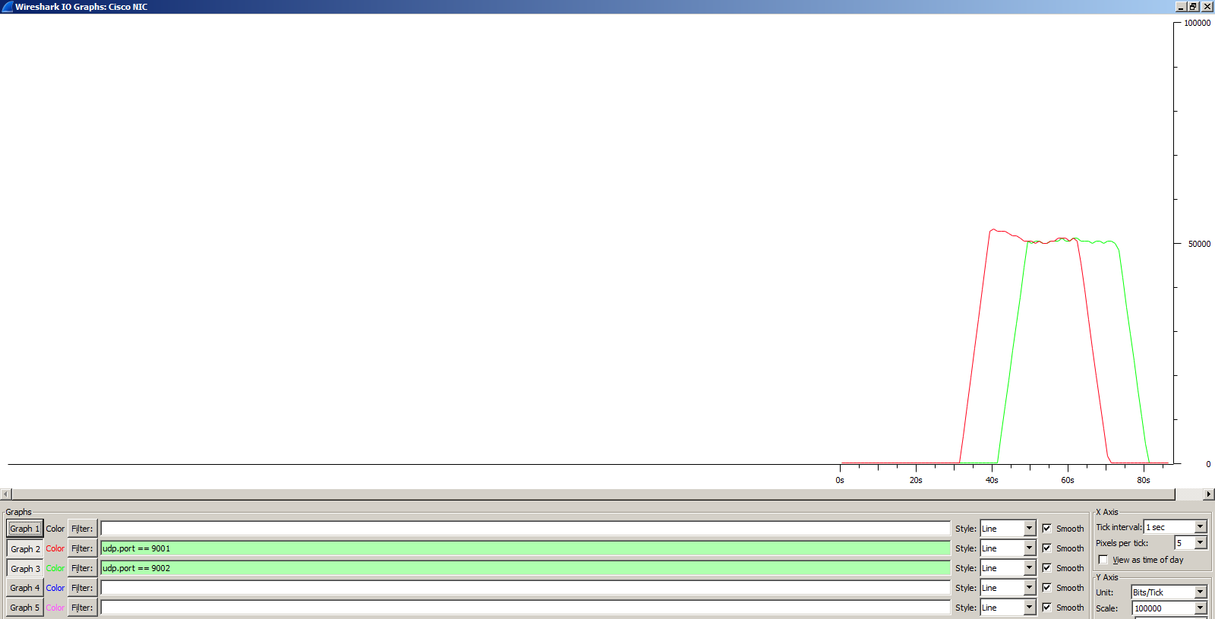

**Obrázok 4 Správanie tokov pri intenzite tokov 12pkt/s a PQ**

Výpis z loggera ukazuje, že nedochádzalo k stratám čo sa aj predpokladalo.

ITGDec version 2.8.1 (r1023)

Compile-time options:

----------------------------------------------------------

Flow number: 1

From 10.0.1.10:53203

To 10.0.2.10:9001

----------------------------------------------------------

Total time = 30.324000 s

Total packets = 360

Minimum delay = -279.629000 s

Maximum delay = -279.208000 s

Average delay = -279.406183 s

Average jitter = 0.003914 s

Delay standard deviation = 0.087939 s

Bytes received = 184320

Average bitrate = 48.626830 Kbit/s

Average packet rate = 11.871785 pkt/s

Packets dropped = 0 (0.00 %)

Average loss-burst size = 0.000000 pkt

----------------------------------------------------------

----------------------------------------------------------

Flow number: 2

From 10.0.1.10:53204

To 10.0.2.10:9002

----------------------------------------------------------

Total time = 30.629000 s

Total packets = 360

Minimum delay = -285.071000 s

Maximum delay = -284.354000 s

Average delay = -284.867244 s

Average jitter = 0.003827 s

Delay standard deviation = 0.216237 s

Bytes received = 184320

Average bitrate = 48.142610 Kbit/s

Average packet rate = 11.753567 pkt/s

Packets dropped = 0 (0.00 %)

Average loss-burst size = 0.000000 pkt

----------------------------------------------------------

__________________________________________________________

**************** TOTAL RESULTS ******************

__________________________________________________________

Number of flows = 2

Total time = 40.701000 s

Total packets = 720

Minimum delay = -285.071000 s

Maximum delay = -279.208000 s

Average delay = -282.136714 s

Average jitter = 0.074772 s

Delay standard deviation = 2.735515 s

Bytes received = 368640

Average bitrate = 72.458171 Kbit/s

Average packet rate = 17.689983 pkt/s

Packets dropped = 0 (0.00 %)

Average loss-burst size = 0 pkt

Error lines = 0

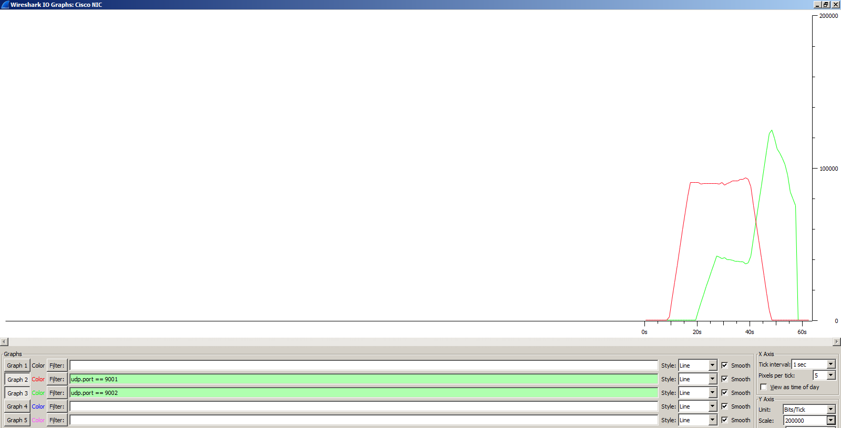

**Obrázok 5 Správanie tokov pri intenzite tokov 21pkt/s a PQ. Prioritu mal prvý tok (červený)**

Logger potvrdzuje nastavenia a správanie tokov. Keďže prvý tok bol priroitný, jeho pakety odchádzali z rozhrania ako prvé a nedochádzalo k stratám. Druhý tok, naopak, trpel veľkými stratami.

ITGDec version 2.8.1 (r1023)

Compile-time options:

----------------------------------------------------------

Flow number: 1

From 10.0.1.10:62256

To 10.0.2.10:9001

----------------------------------------------------------

Total time = 30.762000 s

Total packets = 630

Minimum delay = -281.187000 s

Maximum delay = -280.361000 s

Average delay = -280.723665 s

Average jitter = 0.011773 s

Delay standard deviation = 0.258397 s

Bytes received = 322560

Average bitrate = 83.885313 Kbit/s

Average packet rate = 20.479813 pkt/s

Packets dropped = 0 (0.00 %)

Average loss-burst size = 0.000000 pkt

----------------------------------------------------------

----------------------------------------------------------

Flow number: 2

From 10.0.1.10:62257

To 10.0.2.10:9002

----------------------------------------------------------

Total time = 30.779000 s

Total packets = 458

Minimum delay = -282.590000 s

Maximum delay = -274.390000 s

Average delay = -279.189983 s

Average jitter = 0.036379 s

Delay standard deviation = 2.600340 s

Bytes received = 234496

Average bitrate = 60.949608 Kbit/s

Average packet rate = 14.880276 pkt/s

Packets dropped = 172 (27.30 %)

Average loss-burst size = 1.387097 pkt

----------------------------------------------------------

__________________________________________________________

**************** TOTAL RESULTS ******************

__________________________________________________________

Number of flows = 2

Total time = 41.009000 s

Total packets = 1088

Minimum delay = -282.590000 s

Maximum delay = -274.390000 s

Average delay = -280.078052 s

Average jitter = 0.045066 s

Delay standard deviation = 1.859682 s

Bytes received = 557056

Average bitrate = 108.669999 Kbit/s

Average packet rate = 26.530762 pkt/s

Packets dropped = 172 (13.65 %)

Average loss-burst size = 1.387097 pkt

Error lines = 0

* Experimenty s WFQ

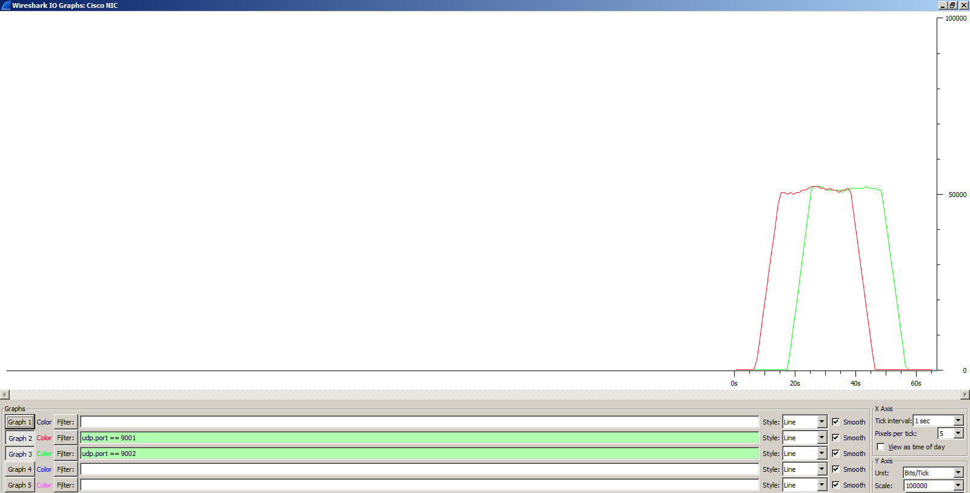

**Obrázok 6 Správanie tokov pri intenzite 12pkt/s a WFQ**

Výpis z loggera:

ITGDec version 2.8.1 (r1023)

Compile-time options:

----------------------------------------------------------

Flow number: 1

From 10.0.1.10:62258

To 10.0.2.10:9001

----------------------------------------------------------

Total time = 31.172000 s

Total packets = 360

Minimum delay = -274.962000 s

Maximum delay = -273.707000 s

Average delay = -274.308517 s

Average jitter = 0.004961 s

Delay standard deviation = 0.359384 s

Bytes received = 184320

Average bitrate = 47.303991 Kbit/s

Average packet rate = 11.548826 pkt/s

Packets dropped = 0 (0.00 %)

Average loss-burst size = 0.000000 pkt

----------------------------------------------------------

----------------------------------------------------------

Flow number: 2

From 10.0.1.10:62259

To 10.0.2.10:9002

----------------------------------------------------------

Total time = 30.988000 s

Total packets = 360

Minimum delay = -276.184000 s

Maximum delay = -275.113000 s

Average delay = -275.669822 s

Average jitter = 0.004877 s

Delay standard deviation = 0.306222 s

Bytes received = 184320

Average bitrate = 47.584872 Kbit/s

Average packet rate = 11.617400 pkt/s

Packets dropped = 0 (0.00 %)

Average loss-burst size = 0.000000 pkt

----------------------------------------------------------

__________________________________________________________

**************** TOTAL RESULTS ******************

__________________________________________________________

Number of flows = 2

Total time = 41.467000 s

Total packets = 720

Minimum delay = -276.184000 s

Maximum delay = -273.707000 s

Average delay = -274.989169 s

Average jitter = 0.027125 s

Delay standard deviation = 0.758124 s

Bytes received = 368640

Average bitrate = 71.119686 Kbit/s

Average packet rate = 17.363204 pkt/s

Packets dropped = 0 (0.00 %)

Average loss-burst size = 0 pkt

Error lines = 0

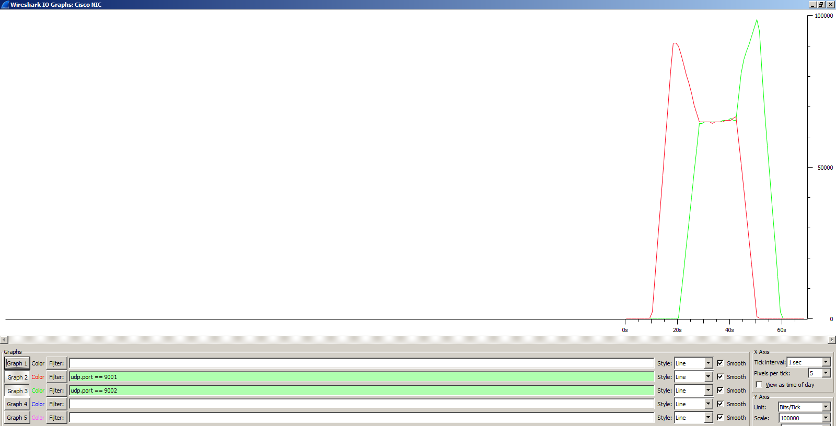

**Obrázok 7 Správanie tokov pri intenzite 21pkt/s a WFQ**

Výpis z logu ukazuje približne rovnomerné straty pre oba toky:

ITGDec version 2.8.1 (r1023)

Compile-time options:

----------------------------------------------------------

Flow number: 1

From 10.0.1.10:63508

To 10.0.2.10:9001

----------------------------------------------------------

Total time = 31.170000 s

Total packets = 516

Minimum delay = -286.935000 s

Maximum delay = -284.584000 s

Average delay = -285.796254 s

Average jitter = 0.014497 s

Delay standard deviation = 0.894486 s

Bytes received = 264192

Average bitrate = 67.806737 Kbit/s

Average packet rate = 16.554379 pkt/s

Packets dropped = 91 (14.99 %)

Average loss-burst size = 1.011111 pkt

----------------------------------------------------------

----------------------------------------------------------

Flow number: 2

From 10.0.1.10:63509

To 10.0.2.10:9002

----------------------------------------------------------

Total time = 31.091000 s

Total packets = 525

Minimum delay = -284.900000 s

Maximum delay = -282.885000 s

Average delay = -283.574373 s

Average jitter = 0.017000 s

Delay standard deviation = 0.462743 s

Bytes received = 268800

Average bitrate = 69.164710 Kbit/s

Average packet rate = 16.885916 pkt/s

Packets dropped = 105 (16.67 %)

Average loss-burst size = 1.000000 pkt

----------------------------------------------------------

__________________________________________________________

**************** TOTAL RESULTS ******************

__________________________________________________________

Number of flows = 2

Total time = 41.360000 s

Total packets = 1041

Minimum delay = -286.935000 s

Maximum delay = -282.885000 s

Average delay = -284.675709 s

Average jitter = 0.035377 s

Delay standard deviation = 1.318590 s

Bytes received = 532992

Average bitrate = 103.093230 Kbit/s

Average packet rate = 25.169246 pkt/s

Packets dropped = 196 (15.84 %)

Average loss-burst size = 1.005128 pkt

Error lines = 0